THE UNDOCUMENTED MIGRATION PROJECT

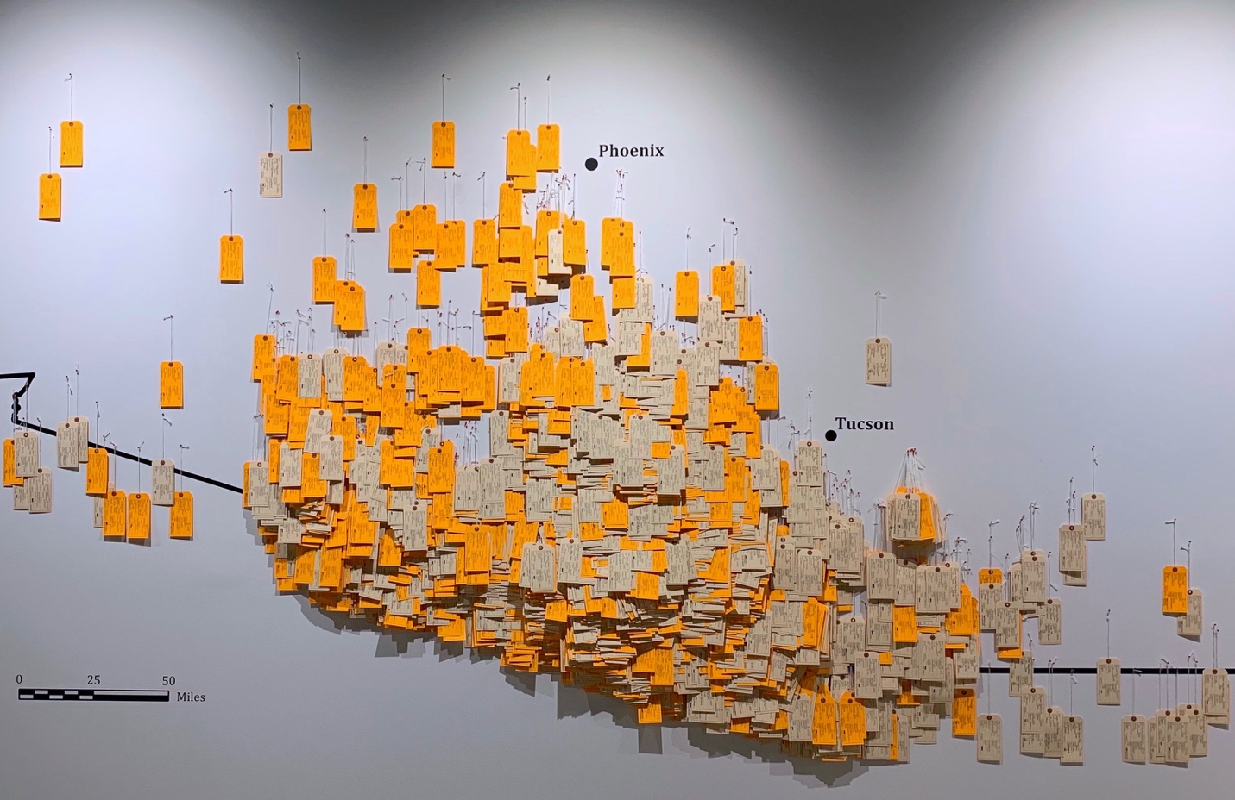

[https://www.facebook.com/ hostileterrain94/](https://www.facebook.com/%20hostileterrain94/)

@HostileTerrain

@HostileTerrain94 @HostileTerrain94lafayette



www.ht94.org

Background

In 1994, the United States Border Patrol launched the immigration enforcement strategy known as “Prevention Through Deterrence” (PTD). This was a policy designed to discourage undocumented migrants from attempting to cross the U.S./Mexico border near urban points of entry, funneling them towards more remote and depopulated regions where the natural environment would act as a physical deterrent. It was anticipated that the difficulties experienced while traversing dozens of miles across the Sonoran Desert, which the Border Patrol deemed as “hostile terrain,” would eventually discourage migrants from making the journey. PTD failed to stop border crossers and, instead, more than six million people have tried to migrate through the desert of Southern Arizona since the 1990s, and at least 3,200 people have died, largely from dehydration and hyperthermia. PTD is still the primary border enforcement strategy being used on the U.S./Mexico border today.

Workshop

To prepare for the installation of Hostile Terrain 94, the Lafayette College community will be coming together to participate in a workshop of reflection to recognize those who have lost their lives while crossing the U.S./Mexico border.

HT94 is made up of handwritten toe tags that represent each person who has died in the Sonoran Desert of Arizona. These tags include names (when known), age, sex, cause of death, condition of body, and location for every person whose body has been recovered. The tags are then placed on a wall map in the exact location where those remains were found.

This workshop will ask volunteers to fill out the toe tags and bear witness to the humanitarian crisis that is happening at our southern border. We are hoping for individuals to emotionally connect with the information being conveyed on the tags, to memorialize and stand in solidarity with these lost lives, and to take part in the greater migration conversation.

HOSTILE TERRAIN 94

**Tag-filling Workshop**

**Dates: Sept. 6th – Oct. 1st**

**Monday to Friday**

**Times: 12:00 pm – 1:00 pm**

**4:00 pm – 5:00 pm**

**Location: Skillman Library**

**Simon Room**

**Community Workshops for the Creation of**